# MA defect within 30 days

Q# 2030873

**Note: Current system date 10/08/2022**

When we open the BBR quote in UWP it shows as Surplus and it has the value when it as created in AP.

Notice that this quote was created on 09/25/2022 and at that time MA was Surplus for the industry class selected “Nail Salons”.

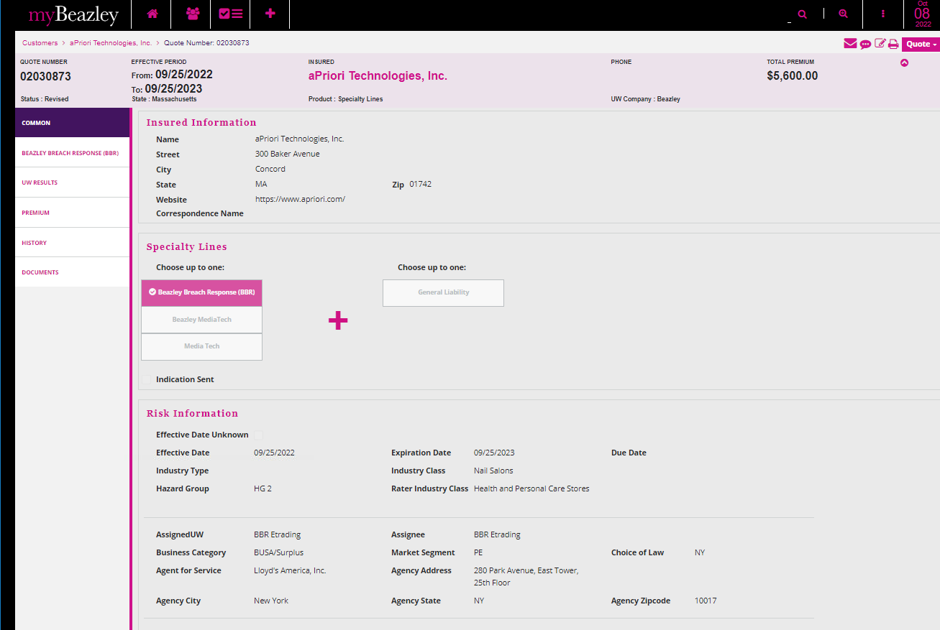

Let’s amend the quote and answer the question Q#2 = NO to force the quote to re-rate. It should re-rate as Admitted using the new rater.

This clears out the quote options and the user has to select one again

As we can see, the quote re-rate to Admitted

The rater shows $2,830.

If I go back to the quote and toggle the industry class to other class that belongs to the same Rater Industry Class and same hazard group HG-2 in this case…

Changed Nail Salons to Barber Shops, this made the quote options to re-rate again, but this time it does it correctly matching with the rater.

And toggle back to “Nail Salons”



